Practical No. 11
Aim : 1) Develop a simple real life application program to illustrate the use of multithreads.

Name : Danish Altaf Solkar | Class : CO - B
Enrolment no. : 24111590805 | Batch : 2

Code :-
class Task implements Runnable {
private String taskName;
public Task(String name) {
this.taskName = name;
}
@Override
public void run() {
System.out.println(taskName + " is starting.");
try {
Thread.sleep(2000); // Simulating work
} catch (InterruptedException e) {
System.out.println(taskName + " was interrupted.");
}
System.out.println(taskName + " is completed.");
}
}
public class MultithreadingExample {
public static void main(String[] args) {
Thread thread1 = new Thread(new Task("Task 1"));
Thread thread2 = new Thread(new Task("Task 2"));
Thread thread3 = new Thread(new Task("Task 3"));
thread1.start();
thread2.start();
thread3.start();
try {
thread1.join();
thread2.join();
thread3.join();
} catch (InterruptedException e) {
System.out.println("Main thread was interrupted.");
}
System.out.println("All tasks are completed.");
}
}

OUTPUT :-
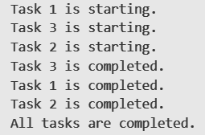

Aim : 4) Implement Multithreading to perform simultaneous process.

Code :-
class Task extends Thread {
public void run() {
for (int i = 0; i < 5; i++) {
System.out.println(Thread.currentThread().getName() + " - Count: " + i);
try {
Thread.sleep(100); // Simulate work
} catch (InterruptedException e) {
e.printStackTrace();
}
}
}
}
public class MultithreadingExample {
public static void main(String[] args) {
Task task1 = new Task();
Task task2 = new Task();

task1.start();
task2.start();
}
}

OUTPUT :-
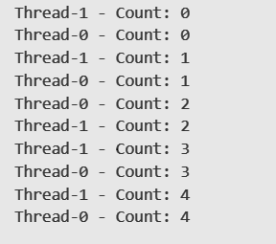
Aim : 5) Create three Threads and run these threads according to setPriority.

Code :-
public class ThreadPriorityExample {
public static void main(String[] args) {
Thread thread1 = new Thread(new Task(), "Thread 1");
Thread thread2 = new Thread(new Task(), "Thread 2");
Thread thread3 = new Thread(new Task(), "Thread 3");
thread1.setPriority(Thread.MIN_PRIORITY);
thread2.setPriority(Thread.NORM_PRIORITY);
thread3.setPriority(Thread.MAX_PRIORITY);
thread1.start();
thread2.start();
thread3.start();
}
}
class Task implements Runnable {
@Override
public void run() {
System.out.println(Thread.currentThread().getName() + " is running with priority: "
+ Thread.currentThread().getPriority());
}
}

OUTPUT :-


